AI-Powered Data Pipeline for E-commerce Warehouse Demand Forecasting

# Implementation Steps

**Data Ingestion Using Terraform and Python**

Data Processing Using AWS Glue & Lambda

Machine Learning with Amazon SageMaker (for demand forecasting)

Model Integration & Optimisation

Deployment & Scaling

Table of Contents

Implementation Steps 1

Step 1. Data Ingestion Using Terraform and Python 3

Objective: 3

Set Up AWS Cloud Shell 3

Create Terraform Files 4

Deploy Terraform Infrastructure 5

Verify Setup 5

Simulate Data Using Python Script 6

Monitoring and Logging 9

Issues Encountered 10

**Problem:** 10

**Solution:** 10

Summary of Key Deliverables 10

# Step 1. Data Ingestion Using Terraform and Python

## Objective:

* Use Terraform to set up Amazon Kinesis and Amazon S3 for real-time data ingestion.
* Simulate sales and inventory data using a Python script to mimic multiple warehouse systems.

## **Set Up AWS Cloud Shell**

1. Verify terraform installation.

1. If the Terraform version is out of date you can update it as shown below:

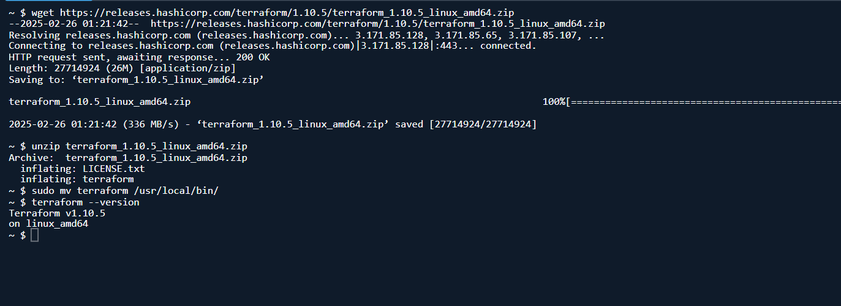

## Create Terraform Files

* 1. Create a directory and navigate into that directory

* 1. Create a main.tf file which when applied will create an S3 bucket to store sales data, configure Amazon Kinesis Firehose to receive and send real-time data to this bucket, and establish IAM roles and policies that grant Firehose secure access to the bucket.

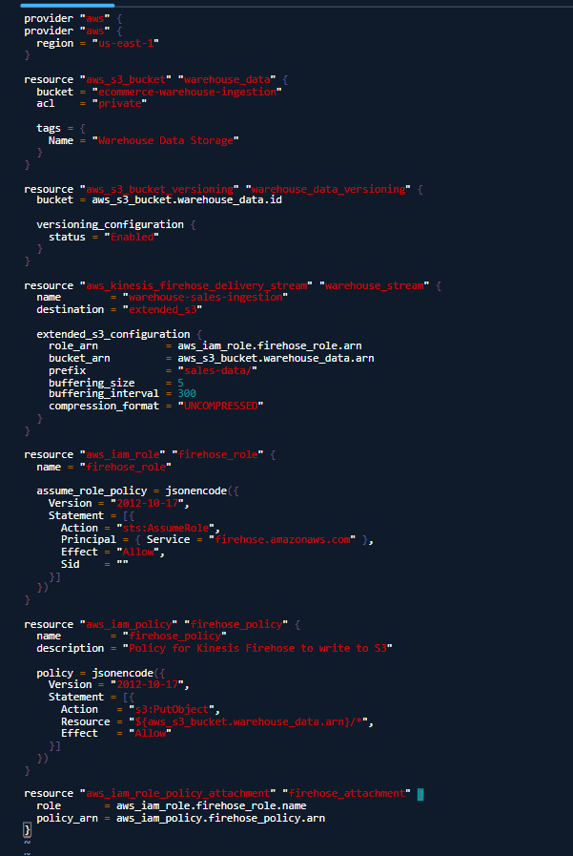

## Deploy Terraform Infrastructure

1. Terraform Init

1. Terraform Plan

1. Terraform Apply

## Verify Setup

1. Check S3 Bucket: Go to AWS Console → S3 → Ensure the bucket is created.

1. Check Kinesis Firehose: Go to AWS Console → Kinesis → Ensure the firehose stream is created.

## Simulate Data Using Python Script

1. **Upload Python Script to AWS Cloud Shell.**

1. Install required libraries

1. Configure AWS CLI

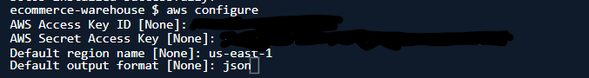

1. Upload the code for the Simulation

1. Run the simulation

1. Verify data in Amazon S3

## Monitoring and Logging

1. Monitor Kinesis Firehose: AWS Console → Amazon Kinesis → Delivery Streams → Monitoring tab. Check data delivery success, throughput, and error logs.

## Issues Encountered

### **Problem:**

While running terraform plan, we encountered an *unsupported block type* error related to s3_configuration. The error indicated that s3_configuration was no longer supported for the aws_kinesis_firehose_delivery_stream resource.

### **Resolution:**

To resolve this, we replaced s3_configuration with extended_s3_configuration, which is the correct format for newer versions of Terraform. Additionally, we addressed the deprecation warning for acl = "private" by removing it and relying on the default settings. After making these corrections, Terraform successfully created the necessary resources.

# Summary of Key Deliverables

1. **AWS Cloud Shell:** Configured to run Terraform and Python scripts.
2. **Terraform Deployment:** Kinesis Firehose and S3 bucket deployed using Terraform.
3. **Python Data Simulation:** Sales and inventory data simulated and sent to Kinesis Firehose.
4. **Real-Time Data Storage:** Data delivered to S3 and verified in the sales-data/ folder.
5. **Monitoring:** Kinesis Firehose and CloudWatch Logs configured for performance monitoring.